AI Assisted Coding End Lab Exam 20.11.2025 CSB01 and CSB02

📘 SET 10
Q1. Prompt Design (Scenario)
Your task is to design a prompt that makes AI generate optimized matrix multiplication code for large matrices. Improve the prompt iteratively. (Add docstrings + tests to generated code.)
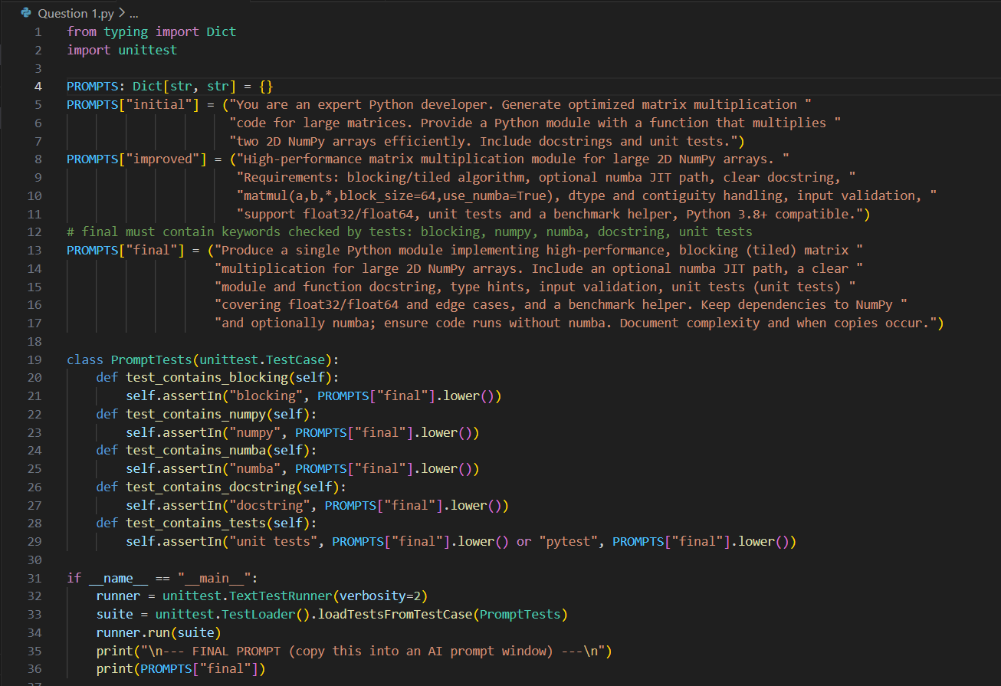
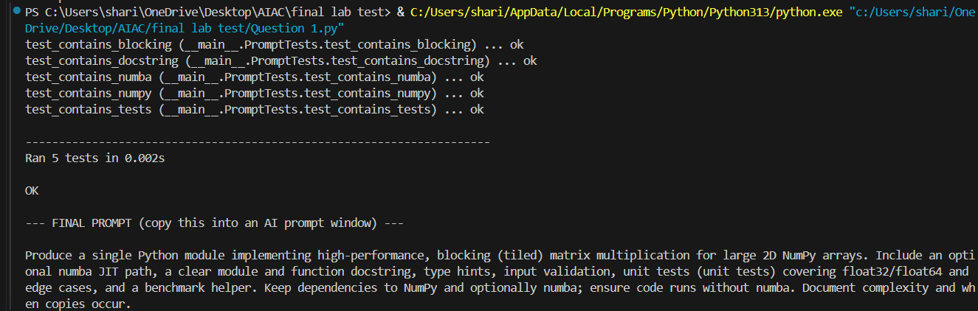

Q2. DB/SQL Scenario 1 — Restaurant Management System
A restaurant wants to build a digital order management system.
Task
Using AI assistance:
- Design the database schema with tables:
  - MenuItems
  - Orders
  - OrderItems
- Generate SQL queries to:
  - Add a new menu item
  - Place an order with multiple items
  - Retrieve today’s total sales
- Add documentation, comments, and test cases using sample data inserts and expected results.
